Use the following steps to save a Word document as file type HTML.

1. Open the document in Word. From the menu bar, select File 🡪 Save As
2. Select More options…

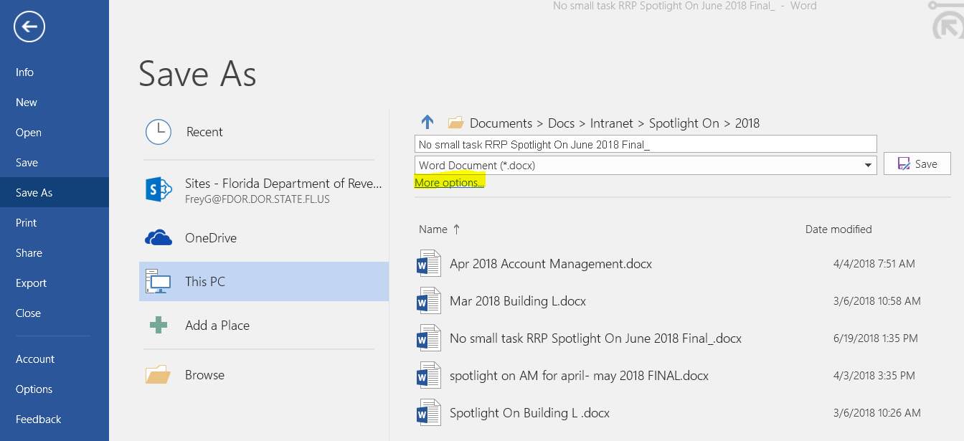

1. Select the Tools dropdown arrow, then select from the list Web Options…:

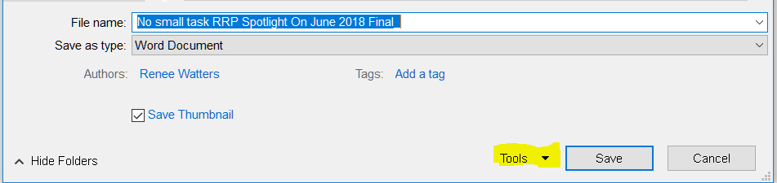

1. Select the Encoding tab, then using the “Save this document as:” dropdown arrow, select from the list “Unicode (UTF-8)”, then click “OK”

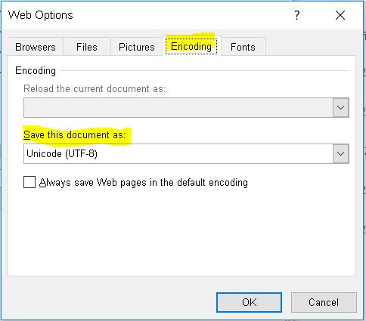

**Note:** You should only have to make this change when saving the first document as an HTML.

1. Select the “Save as type:” dropdown arrow, select from the list “Web Page, Filtered”, then click “Save”.

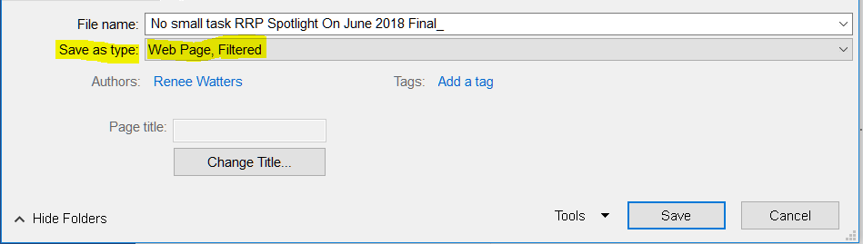

1. Using a code editor, open the HTML file saved in the above steps
2. Delete the <style></style> tag
3. Within the <p></p> tags, delete the <span></span> tag

**Note:** You can select the <span></span> tag, then select Ctrl-d. This will highlight the alike tags, so you can easily move to the next tag.

1. From the menu, select File 🡪 Save.